|  |  |
| --- | --- |
| Anti-lock Braking System Suraj PundhirUnique ID:2005058 |  |
|  |  |

Table of Contents

1)Introduction – Anti-Lock Braking System(ABS)

2)Problem Statement

3)Formula used

4) Major skills used in the project

* Call Backs
* Data Inspector
* Solver
* Matlab Function Block
* Look up Table
* Signal Builder

5) References

Introduction – Anti-Lock Braking Sytem(ABS)

## 

## Fig-1

Even if you’re an experienced driver, unexpected trouble sometimes can get in the way. In an attempt to avoid imminent collision or danger on the road ahead, you may find yourself jumping on the brake.

This is where the anti-lock braking system (ABS) comes in. It prevents the wheels from locking up and helps them maintain grip with the road below.

ABS was first introduced as an anti-skid system for aircraft use in the 1950s. And in the 1970s, Ford and Chrysler proved that it can also be used in cars. Anti-lock braking systems are now present in all modern cars.

**Q- How does it work ?**

ABS is part of an overall stability system, commonly known as electronically stability control, which monitors wheels’ under heavy braking. Each wheel has a sensor attached to it.

If the intelligent sensors detect that a wheel is about to lock up and stop moving, the system will release the brake. The release is only for a moment.

ABS then continuously and repeatedly applies optimum braking pressure to each wheel, meaning the system will brake just enough to not lock the wheels.

When ABS is active you may feel pulsation through the brake pedal as you’re pressing it. The anti-lock system helps the driver remain in control of the vehicle rather than bringing the car to a stop.

It reduces the risk of skidding even when undertaking excessive evasive manoeuvres. This is why it’s important to remember that the car’s braking distance may increase.

So, if you keep driving ahead straight into an obstacle, the car may not stop in time even if your instincts dictate otherwise. It’s a common misconception that ABS helps reducing stopping distance.

Problem Statement

In this Project I have dealt with a problem of locking during braking

The problem is-

A 4 Wheeled vehicle is to decelerate from a speed to standstill without wheel locking.The Co-efficient of friction between the tyres and the road is known. The desired wheel slip is 0.2.

Formula used

There are various formula used to develop this model .Some of them is mentioned below-

Formula-1

Relative slip = 1-{(Vehicle angular velocity)/(Wheel angular velocity)}

Formula-2

Tyre Torque=u*N*R

u- Co-efficient of friction

N- Normal Force/Wheel

Where N=(m*g)/4

m- mass of the vehicle

R- Wheel Radius

Formula-3

Equivalent vehicle angular acceleration = -Tyre torque/(Vehicle Mass*Wheel Radius)

Note- negative sign is used for deceleration

Formula -4

Equivalent vehicle angular acceleration = Integral of angular acceleration.

Skills Highlighted

1. Call Backs Function

In this project for variable variables and certain parameter model call back up function is used.

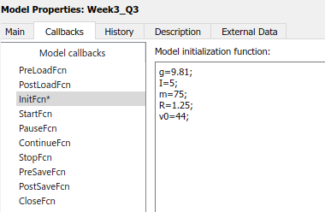

Fig-2

1. Data Inspector

Data inspector which is used to inspect values at variable input values have been used in this project.

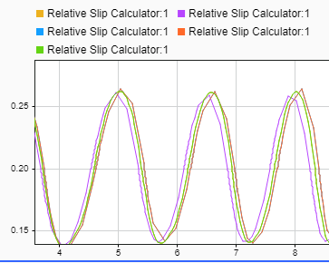

Fig-3

1. Solver

To solve this problem various solver is tried and tested according to flow chart

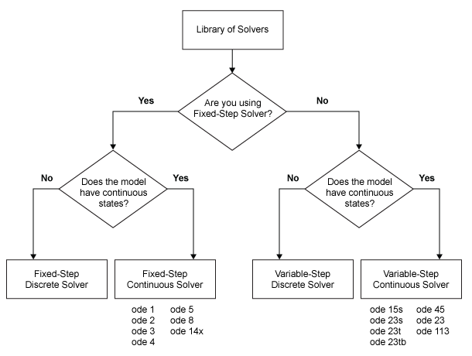

Fig-4

The solver that are tested for this model are ode45,ode15s,ode23s,ode23t etc.

But the most stable braking condition is found in ODE45.

1. Matlab Function Block

In this function block output from the look up table is taken in the form of u and which is forwarded to fuction block.

This function block will model the Normal Force and the wheel radius and outputs the tyre radius.

1. Look-up Table

For this Project a look up table is built for input of co-efficient of friction and slip is outputed by the table of information given below-

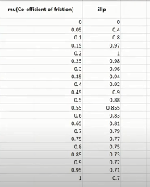

Fig-5

1. Signal Builder

For Providing a wheel slip of 0.2 a signal builder is build in this project.

References:

## Genesis – MBD Training course

## Genesis – AAEL Training Course

## Anti-Lock Braking System – Wikipedia

1. Solver choice for Simulink - <https://blogs.mathworks.com/racing-lounge/2017/12/08/solver-choice/>

1. Modelling of ABS-

<https://in.mathworks.com/help/simulink/slref/modeling-an-anti-lock-braking-system.html>

1. Choose an ODE Solver-

<https://in.mathworks.com/help/matlab/math/choose-an-ode-solver.html>

1. More about ABS-

https://www.confused.com/on-the-road/gadgets-tech/what-is-abs#